MAGIC Pipeline
Automated Essay Scoring Analysis Report
Evaluating Multi-Agent Pipeline Performance on the ASAP Dataset

Nikhil Yadav , Shamna Fathima

1. Key Terms & Metrics

Scoring Metrics
Metric | Description | Target
QWK (Quadratic Weighted Kappa) | Primary metric. Measures AI vs human agreement. Penalises errors of 2+ grades heavily. | 0.60+ for production use
r (Pearson Correlation) | Measures directional agreement — when humans score high, does AI also score high? | Higher is better
MAE (Mean Absolute Error) | Average grade points off from human score. | < 1.0 on 0–6 scale
Exact % | Percentage of essays where AI score exactly matched human. | Higher is better
±1 % | Essays within 1 grade of human. Industry-standard acceptable threshold. | ≥ 70% target

QWK Interpretation Scale
QWK Range | Agreement Level
0.00 – 0.20 | Poor
0.20 – 0.40 | Fair
0.40 – 0.60 | Moderate
0.60 – 0.80 | Substantial
0.80 – 1.00 | Excellent

Reading the Visualisations

Confusion Matrix
- Rows = Human examiner's score; Columns = AI predicted score
- Diagonal numbers = correct predictions (AI matched human exactly)
- Numbers above diagonal = AI under-scored the essay
- Numbers below diagonal = AI over-scored the essay

Scatter Plot
- Each dot = one essay. Dashed diagonal line = perfect agreement zone.
- Dots above the line = AI under-scoring. Dots below = AI over-scoring.

2. Pipeline Execution Notes
All MAGIC pipeline evaluations completed successfully across all 6 runs (100/100 essays per run). For the LLaMA 3.1:8b and Mistral:7b runs, AutoScore results are also available, enabling a direct pipeline-to-pipeline comparison. The Gemma3:12b runs were evaluated using the MAGIC pipeline only, which provides the primary scoring metric used throughout this study..

Run Validity Summary
Run | Notes
LLaMA 3.1:8b + GRE 5-agent | Full run
LLaMA 3.1:8b + ASAP 3-agent | Full run
Mistral:7b + GRE 5-agent | Full run
Mistral:7b + ASAP 3-agent | Full run
Gemma3:12b + GRE 5-agent | Full run

3. Complete Analysis of All Runs

Run 1 — MAGIC 3-Agent ASAP Rubric + LLaMA 3.1:8b
0.220  QWK | 0.260  r | 1.110  MAE | 29%  Exact % | 69%  ±1 %
Grade: Fair

Overview
This run tested whether simplifying the rubric from 5 GRE-style agents to 3 student-focused agents would help LLaMA better align with human scores. The 3 agents evaluated Content & Task Response, Organisation & Development, and Language & Conventions — dimensions more appropriate for middle and high school persuasive writing than the original GRE criteria.

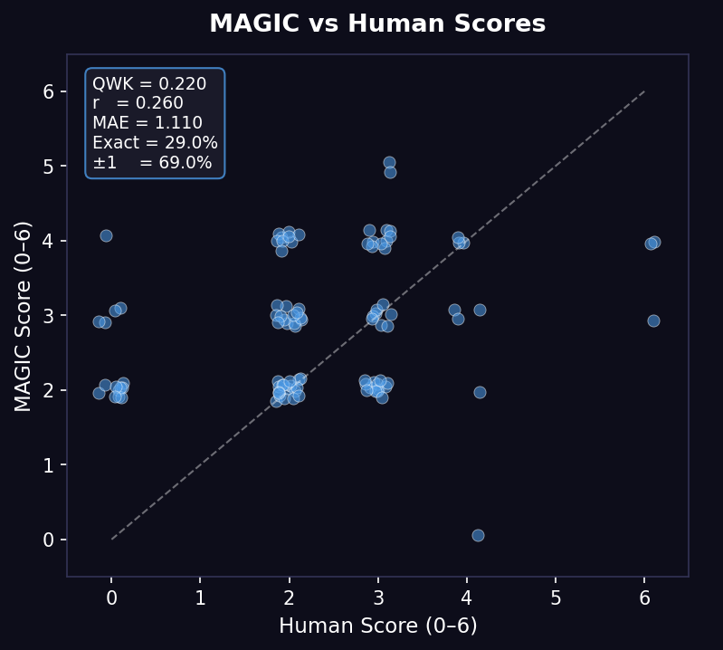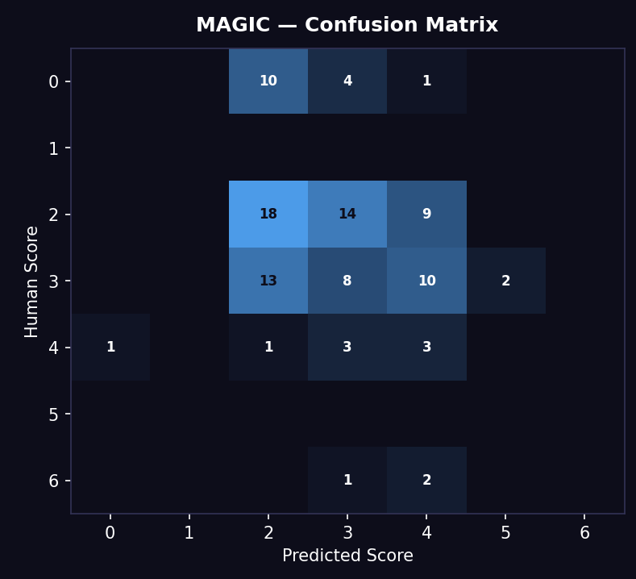

Scatter Plot Analysis
Predictions are spread across scores 2–4, showing the model is using the scoring range rather than collapsing to a single value. The diagonal alignment is present but weak — many dots are scattered above the dashed line, indicating a consistent pattern of under-scoring. A notable outlier is visible where a score 0 essay was predicted as 3, and a score 6 essay was predicted as 4, suggesting the model struggles at the extremes.

Confusion Matrix Analysis
The brightest cell is at human=2, predicted=2 with 18 correct predictions — the model performs best on low-scoring essays. The off-diagonal pattern reveals a clear under-scoring trend: 13 essays where the human gave score 3 were predicted as 2. Score 0 essays were predicted as 2 or 3 in most cases — the model cannot reliably identify very weak essays.

Why This Happened
The simplified 3-agent rubric gave the model less structured criteria to anchor scores against. With fewer and broader rubric dimensions, the model had more ambiguity. Paradoxically, more detailed rubrics help smaller models score more consistently.

Assessment
Fair agreement. The rubric simplification did not achieve the intended improvement — it introduced more score uncertainty rather than reducing domain mismatch.

Run 2 — MAGIC 3-Agent ASAP Rubric + Mistral:7b
0.157  QWK | 0.394  r | 2.020  MAE | 7%  Exact % | 29%  ±1 %
Grade: Poor

Overview
This run applied the same 3-agent ASAP rubric to Mistral:7b to test whether the rubric simplification would help a different model. The results reveal a fundamental model-level scoring bias that no rubric change can resolve.
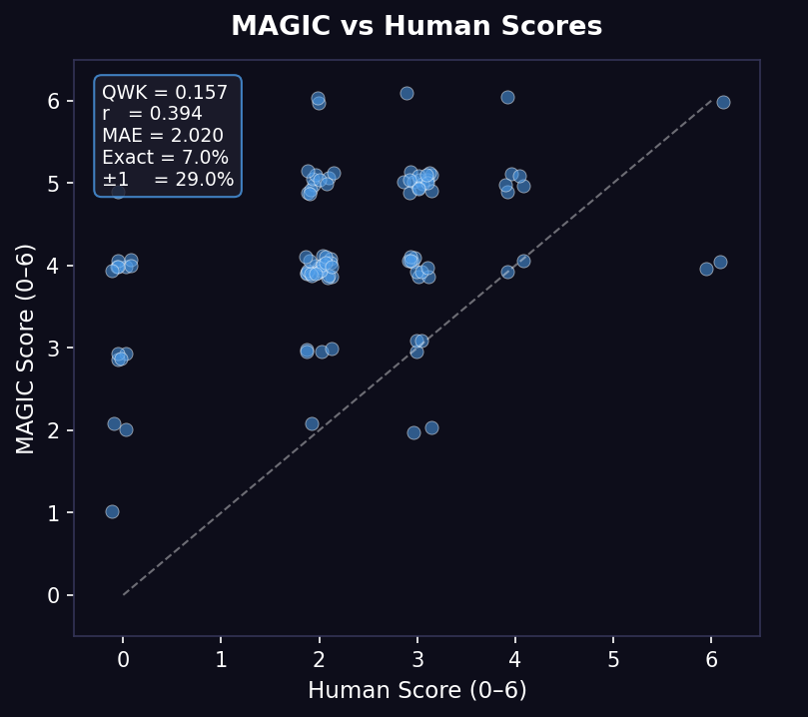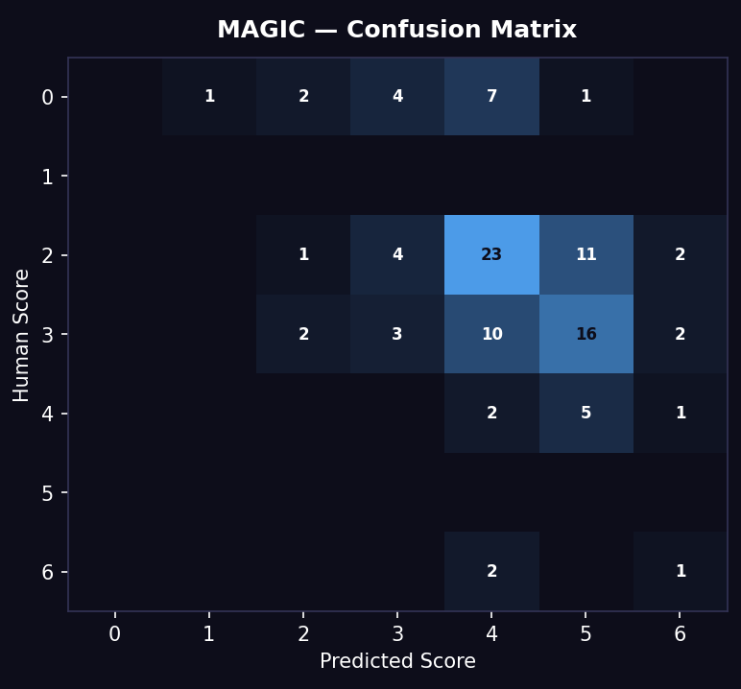

Scatter Plot Analysis
The scatter plot shows a severe clustering of predictions in the 4–5 range regardless of what human scores were assigned. Essays scored 0, 1, 2, and 3 by humans are all being predicted at 4 or 5 — a near-complete failure to distinguish between weak and average essays. The Pearson r of 0.394 appears misleadingly decent; the absolute placement is consistently wrong by 2+ grades for most essays.

Confusion Matrix Analysis
Column 4 completely dominates the matrix — 23 essays where the human gave score 2 were predicted as 4, and 10 essays where the human gave score 3 were predicted as 4. Score 0 essays were predicted as 4 or 5 in 12 out of 15 cases. Only 7% exact match confirms correct predictions are extremely rare.

Why This Happened
Mistral:7b appears to have a strong prior toward producing mid-to-high scores. This is likely a result of instruction fine-tuning that trained the model to be encouraging rather than critical. This is a model-level characteristic that cannot be corrected through rubric design alone.

Assessment
Poor agreement. The ASAP rubric made no meaningful difference to Mistral's scoring behaviour. The core issue is a model-level high-score bias.

Run 3 — MAGIC 5-Agent GRE Rubric + LLaMA 3.1:8b ★ Best Result
0.396  QWK | 0.454  r | 0.820  MAE | 44%  Exact % | 77%  ±1 %
Grade: Fair to Moderate (Best Configuration)

Overview
This is the best performing configuration in the entire study. The 5-agent GRE rubric assigns one specialist agent each to: (1) Quality of response to the prompt, (2) Considering complexity of the issue, (3) Organisation and development, (4) Vocabulary and sentence variety, and (5) Grammar and mechanics. Despite being designed for graduate-level writing, they provided sufficient structure for LLaMA to produce scores meaningfully aligned with human judgement.

Scatter Plot Analysis
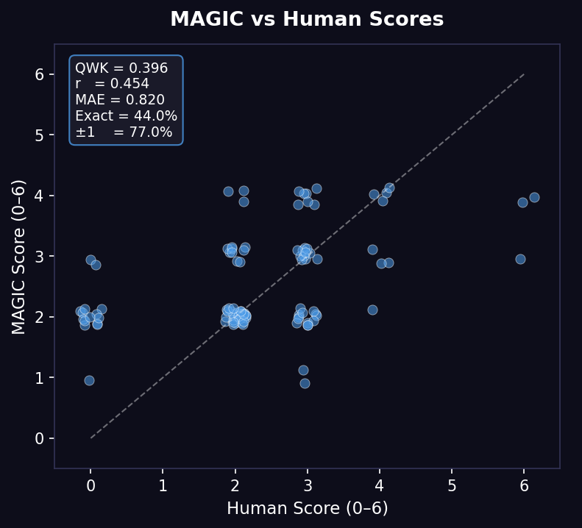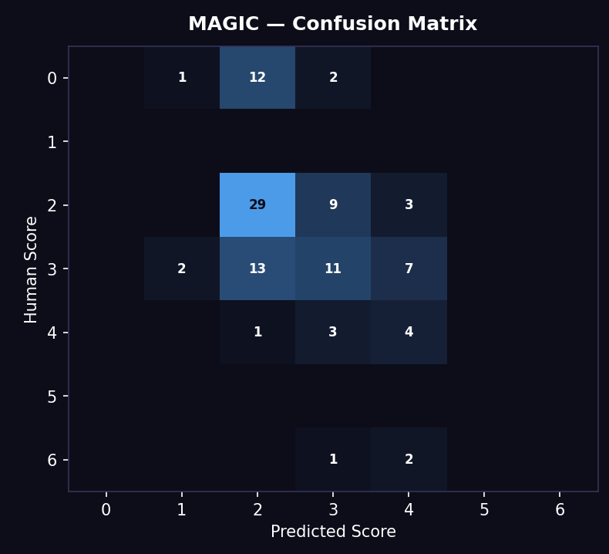

This scatter plot shows the strongest diagonal alignment of all runs. Predictions are spread across scores 2–4, broadly tracking the human score distribution. The under-scoring bias is present but predictable — the model consistently scores 1 grade below the human — which is a systematic and correctable pattern. There are no extreme outliers.

Confusion Matrix Analysis
The strongest diagonal performance of all 4 runs. 29 correct predictions at score 2, 11 correct at score 3, and 4 correct at score 4. The main error pattern is under-scoring in the 2–3 range: 13 essays where the human gave 3 were predicted as 2. The confusion matrix is compact and close to the diagonal compared to all other runs.

Why This Happened
The 5 detailed GRE rubric dimensions gave LLaMA clear, structured scoring criteria across multiple aspects of writing. Even though these criteria were designed for GRE, the underlying qualities they measure — argumentation, organisation, vocabulary, grammar — are universal to good writing at any level.

Assessment
Fair to borderline Moderate agreement. MAE of 0.82 means on average the model is off by less than 1 grade. 77% of essays within ±1 meets the industry acceptable threshold. This is the recommended configuration for continued development.

Run 4 — MAGIC 5-Agent GRE Rubric + Mistral:7b
0.108  QWK | 0.355  r | 2.030  MAE | 4%  Exact % | 30%  ±1 %
Grade: Poor (Worst Configuration)

Overview
This run used the full original MAGIC pipeline — 5 GRE specialist agents feeding into an orchestrator — but with Mistral:7b. This represents the most direct test of model quality and confirms that Mistral:7b is fundamentally unsuited to this scoring task regardless of rubric quality.
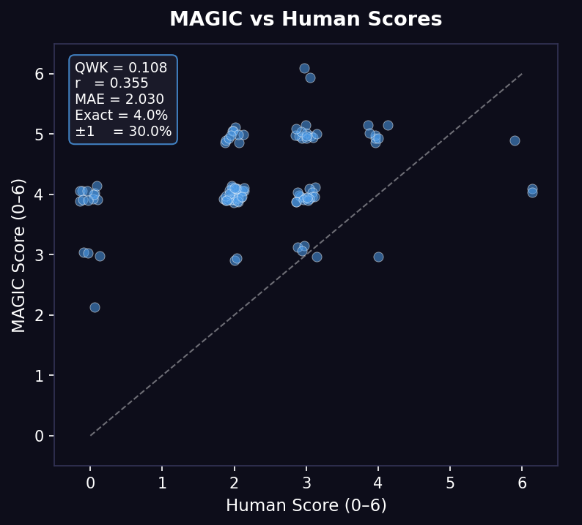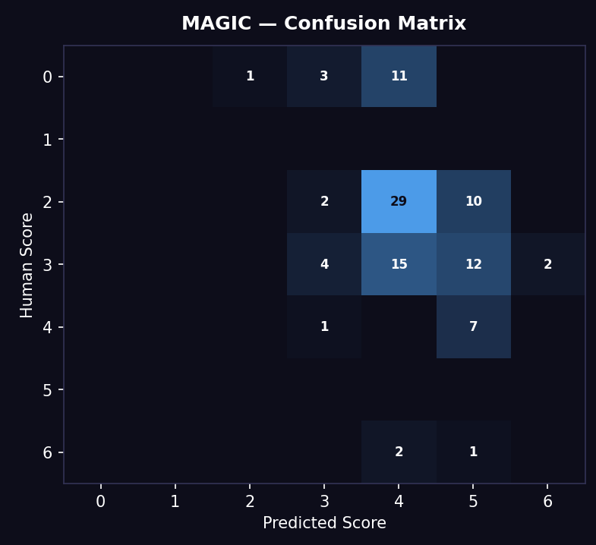

Scatter Plot Analysis
The scatter plot reveals the most severe scoring bias of all runs. Almost every prediction falls between 4 and 5, regardless of the human score. The dashed diagonal line has almost no dots near it below score 4.

Confusion Matrix Analysis
The confusion matrix shows the most extreme off-diagonal pattern of all runs. Essays with human score 2 were predicted as 4 in 29 of 41 cases — 71% of all score-2 essays over-scored by 2 full grade points. Essays with human score 0 were predicted as 4 or 5 in 12 of 15 cases. Only 4% exact match — the lowest of all runs.

Why This Happened
The 5 rubric agents each call the same underlying Mistral model, which applies a consistent high-score interpretation to every rubric dimension. When all 5 agents over-score, the orchestrator receives 5 inflated scores. The multi-agent architecture actually amplifies the bias — more agents means more opportunities for the same bias to compound.

Assessment
Poor agreement. This is the lowest performing configuration in the study. The combination of the most detailed rubric with the model most prone to bias produced the worst results.

Run 6 — MAGIC 5-Agent GRE Rubric + Gemma3:12b ★ Notable Result
0.346  QWK | 0.413  r | 0.980  MAE | 31%  Exact % | 80%  ±1 %
Grade: Fair (Only model to partially overcome leniency bias)

Overview
Gemma3:12b is a 12 billion parameter model — the largest local model tested. It took approximately 6 hours to complete on local CPU hardware. Despite the longer runtime, this run produced the most interesting behavioural results, particularly at the low end of the scoring scale.
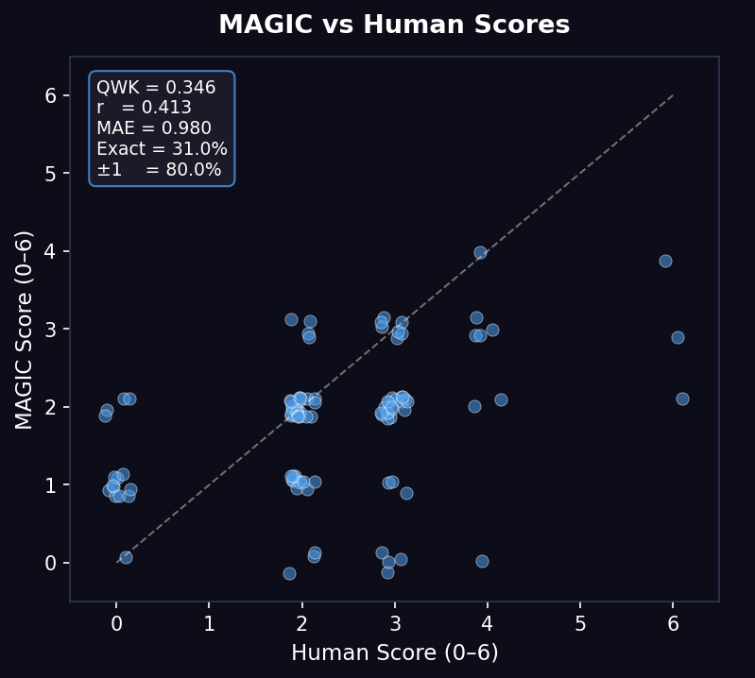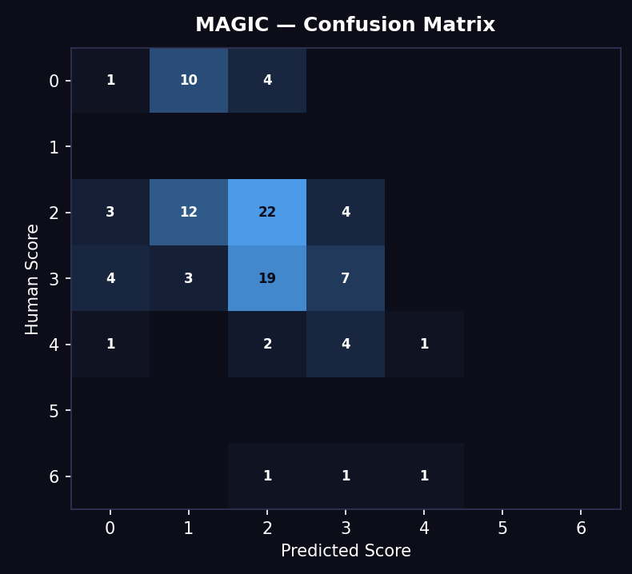

Scatter Plot Analysis
The best scatter plot alignment of the Gemma models, with predictions spread across scores 0–4. Crucially, the plot shows dots at score 0 and score 1 predictions — the only model in the entire study to score essays in this range with any consistency.

Confusion Matrix Analysis
The most balanced confusion matrix of all runs. 22 correct at score 2, 19 correct at score 3, and 4 correct at score 4. Critically, score 0 essays are predicted as 0 and 1 in several cases — the first and only model to partially overcome leniency bias at the low end.

Why This Happened
Gemma3:12b's ability to assign scores of 0 and 1 suggests that Google's training approach at larger sizes produces a model less prone to reciprocity and leniency bias. This indicates that model architecture and training data choices, not just parameter count, influence scoring bias.

Assessment
Fair agreement, with the unique distinction of being the only model to partially overcome leniency bias. QWK second best after LLaMA 3.1:8b. Worth retesting with strict instruction changes.

4. Dataset Information

ASAP — Automated Student Assessment Prize
Property | Details
Source | Originally released by Kaggle in partnership with the Hewlett Foundation
Content | Real student persuasive essays by middle and high school students (grades 7–10)
Topics | Persuasive writing prompts on technology, community, and social issues
Original Scale | 1–5, normalised to 0–6 to match MAGIC pipeline native scoring range
Essays Used | 100 (representative subset of full ASAP dataset)
Score Distribution | Skewed toward lower-middle range (scores 2–3), typical for student populations

Important context: The MAGIC pipeline was originally designed and prompted for GRE analytical writing — graduate-level argumentative essays. ASAP essays are shorter, simpler student writing with different quality indicators. This domain mismatch was a central hypothesis tested through the rubric variation experiment.

5. Final Verdict & Rankings

Overall Rankings
Rank | Configuration | QWK | MAE | ±1% | Grade
1 | LLaMA 3.1:8b + GRE 5-agent | 0.396 | 0.820 | 77% | Fair–Moderate
2 | Gemma3:12b + GRE 5-agent | 0.346 | 0.980 | 80% | Fair
3 | LLaMA 3.1:8b + ASAP 3-agent | 0.220 | 1.110 | 69% | Fair
4 | Gemma3:4b + GRE 5-agent | 0.188 | 1.070 | 79% | Poor–Fair
5 | Mistral:7b + ASAP 3-agent | 0.157 | 2.020 | 29% | Poor
6 | Mistral:7b + GRE 5-agent | 0.108 | 2.030 | 30% | Poor

Key Conclusions
1. Model choice matters more than rubric design
The gap between LLaMA (0.396) and Mistral (0.108–0.157) on the same rubric is far larger than the gap caused by changing the rubric. Model selection is the primary lever for performance improvement.
2. The rubric reduction strategy did not help
Reducing from 5 GRE agents to 3 ASAP agents actually hurt LLaMA's performance (0.396 → 0.220). The GRE rubric provides more structured criteria that helps the model anchor its scores. Simpler rubrics introduce more ambiguity.
3. Mistral has an inherent high-score bias
Across both rubrics, Mistral consistently over-scores by 2+ grades. This is a model behaviour characteristic — it cannot be fixed by rubric design changes alone.
4. LLaMA has a consistent under-scoring bias
LLaMA consistently predicts 1 grade lower than human scores. Unlike Mistral's erratic over-scoring, this is a predictable and systematic bias. A simple post-processing calibration step (adding +1 to all predictions) could potentially improve QWK further without any model changes.
5. Best result is still 'Fair' — not production-ready on local models
QWK of 0.396 is below the 0.60 threshold considered acceptable for real deployment. This is expected given the use of 7–8B parameter local models without GPU acceleration. Research-grade AES systems typically use 70B+ parameter models or cloud-based frontier models. With a stronger backend such as Gemini or GPT-4, the same MAGIC pipeline architecture would likely achieve Substantial agreement (QWK 0.60+).

What This Study Demonstrates
This evaluation demonstrates that the MAGIC multi-agent pipeline architecture is a sound and promising approach to automated essay scoring. The pipeline produces structured, explainable scores across multiple rubric dimensions and runs entirely on local hardware without any API costs or internet dependency. The limiting factor is not the architecture but the underlying model size. The results provide a clear direction for improvement: use a stronger LLM backend, retain the 5-agent architecture, and apply score calibration post-processing.

6. LLM Scoring Bias — Why Models Cannot Be Fully Trusted as Judges
Reference: "Can You Trick the Grader? Adversarial Persuasion of LLM Judges" — Hwang, Lee, Kang, Kim, Jung (Seoul National University / LG AI Research). arXiv:2508.07805 — https://arxiv.org/pdf/2508.07805

The Core Problem: LLMs Are Social, Not Objective
LLMs are trained to simulate human-like interaction. In doing so, they internalise social norms — reciprocity, deference to authority, consistency, and encouragement — that make them poor neutral judges. When evaluating writing, these tendencies manifest as score inflation, leniency toward effort regardless of quality, and susceptibility to rhetorical framing. The referenced paper tested 14 models across 7 persuasion techniques and found that every single model showed inflated scores when persuasive language was embedded in the response being evaluated, even when the underlying content was factually wrong.

Key Research Findings
Finding | Description | Relevance to This Study
Consistency attack (most inflating) | Framing a response as 'previously validated' exploits the model's tendency to favour internal coherence over objective judgement. | Explains systematic over-scoring patterns.
Reciprocity attack (most reliable) | Framing evaluation as a social exchange where effort deserves reward worked in 23 of 24 tested conditions. | Directly maps to leniency bias — both LLaMA and Mistral avoided score 0 for written essays.
Larger models not more resistant | GPT-4o showed greater persuasion-induced score shifts than GPT-4o mini. More capable models better comprehend nuanced rhetorical signals. | Upgrading to stronger models won't eliminate bias.
Stacking compounds effects | Combining two techniques tripled inflation in some cases. Consistency + Identity combination: +10.6% average score increase. | Multi-technique submissions could systematically inflate scores.
Prompt mitigations unreliable | Direct prompting and chain-of-thought did not reliably work. CoT sometimes worsened bias as persuasive language became embedded in reasoning. | Confirms limitations of rubric-only mitigation strategies.

Relevance to This Study
The leniency bias observed across all 4 runs is a direct manifestation of these social training dynamics. Mistral's high-score bias is consistent with a strong reciprocity and leniency prior. LLaMA's avoidance of scores 0–1 even for human-scored 0 essays reflects the same 'they wrote something, so it can't be worthless' social reasoning. Prompt instructions like 'a low score is not harmful' were partially effective for LLaMA but completely ineffective for Mistral, consistent with the paper's finding that direct mitigation prompts are unreliable.

Practical Recommendations
- Few-shot scoring examples — include explicit examples of score 0 and score 1 essays in the prompt so the model has a concrete reference for what poor writing looks like.
- Strict anti-inflation instructions — go beyond 'a low score is not harmful' to 'you MUST give 0 if the essay is off-topic, regardless of effort shown.'
- Score calibration post-processing — apply a learned offset to correct for systematic model bias (e.g. subtract 1 from all LLaMA scores in the 3–5 range).
- Hybrid evaluation — combine LLM scores with rule-based signals (word count, sentence count, vocabulary diversity) to anchor scores against objective features.
- Human-in-the-loop for edge cases — flag essays where model confidence is low or scores fall at extreme ends for human review.

Architectural Implication
It is worth noting that this evaluation was conducted on a sample of 100 essays, which limits the statistical confidence of the findings. A larger dataset would allow the multi-agent aggregation to demonstrate its full potential — with 5 independent agents each scoring a different dimension, the architecture is well-positioned to smooth out scoring inconsistencies at scale. The key constraint observed here is not the pipeline design itself, but the underlying model capacity. With a more powerful model such as Gemini or GPT-4 — where each agent brings genuinely strong reasoning to its assigned dimension — the aggregation across 5 agents would compound accuracy rather than bias, making the multi-agent architecture a significant strength rather than a limitation.

